Software Project Management Plan

Team 1

September 28, 2010

Team Members
Cuong Cu
Casey Droneburg
Kyle Emmons
David Haney

Document Control

Change History
Revision | Change Date | Description of changes
V1.0 | 09/28/10 | Initial release

Document Storage
This document is stored in the project’s SVN repository at: http://134.193.128.7/svn/cs451/branches/team1/Team1_SPMP.doc

Document Owner
Casey Droneburg is responsible for developing and maintaining this document.

Table of Contents

1 Overview 4
1.1 Purpose and Scope 4
1.2 Goals and Objectives 4
1.3 Project Deliverables 5
1.4 Assumptions and Constraints 5
1.4.1 Assumptions 5
1.4.2 Constraints 5
1.5 Schedule and Budget Summary 6
1.5.1 Cost Estimate 6
1.5.2 Schedule Summary 6
1.6 Success Criteria 7
1.7 Definitions 7
2 Startup Plan 8
2.1 Team Organization 8
2.2 Project Communications 8
2.3 Technical Process 9
2.4 Tools 9
3 Work Plan 9
3.1 Resource Estimate 9
3.2 Release Plan 9
3.2.1 Plan By Feature 9
3.2.2 Flow Chart 10
3.3 Iteration Plans 10
3.3.1 First Iteration 11
3.3.2 Second Iteration 11
3.3.3 Final Product 11
4 Control Plan 11
4.1 Monitoring and Control 11
4.2 Configuration Management Plan 11
5 Supporting Process Plans 12
5.1 Risk Management Plan 12
5.2 Test Plan 13
5.3 Product Acceptance Plan 13

Overview

Purpose and Scope
Team 1 is interested in creating a mobile application that will be useful to students and give UMKC visibility in the growing field of smartphone apps. The Roo Balance app accomplishes this by giving UMKC Roo Bucks users a way to keep track of their account information on the go.

The Roo Balance app will provide users the ability to log in to their Roo Bucks account via the UMKC.ManageMyID.com website and see their current balance. A second feature will allow users to see a list of merchants that accept Roo Bucks without logging in.

The application will be created for use on a mobile device with an iOS platform, essentially all iPhone, iPad, and iPod touch devices. A proxy server will be established between the iOS app and the UMKC.ManageMyID.com website for efficient maintenance of the software system.

The user interface will be intuitive and simple to navigate, with 95% of new users being able to use the application without referencing the user manual. A user guide and system administration manual will be provided.

Goals and Objectives
The overall objective is to give students an alternative way to keep track of their Roo Bucks account.

Project Goals:
- Create an app that functions as expected, looks great, and earns an A.
- Give UMKC visibility in the mobile application environment.
- Give Professor Burris a cool app to show the department at project end.
- Learn about software engineering and creating a mobile app.
Project Objectives:
- Create a mobile interface with UMKC.ManageMyID.com to give students access to their Roo Bucks account information.
- Create an app that functions in a simple and intuitive manner.
- Provide students with locations to use their Roo Bucks.

Project Deliverables

Date | Deliverable
09/23/10 | Requirements Specification
09/28/10 | Project Plan
10/05/10 | Iteration #1 Plan
10/07/10 | Technical Prototype
10/14/10 | Customer Approved UI Prototype
10/21/10 | Architecture Document
10/28/10 | Iteration #1 Complete
11/11/10 | Test Report
11/18/10 | Iteration #2 Complete
12/02/10 | User Guide and System Administration Manual
12/07/10 | Product Released

Assumptions and Constraints

Assumptions

- UMKC terminals are available and function when we need them.
- Remote MAC Lab will allow our programmers to work away from UMKC.
- Interfacing the app with a proxy server and third-party website is feasible.

Constraints
Constraints:
- The application will run on an iOS platform.
- Approval is required from UMKC to make this an official UMKC app.
- UMKC symbols used in the app must adhere to guidelines the university provides.

Schedule and Budget Summary

Cost Estimate
1 project manager at 4 hours per week for 14 weeks 56 hours * $50/hr = $2800
1 requirements engineer at 4 hours per week for 14 weeks 56 hours * $40/hr = $2240
2 software engineers at 4 hours per week each for 14 weeks 112 hours * $40/hr = $4480
224 hours total, $9520 total, avg, $42.50 per hour

Schedule Summary

Step | Iteration | 1 |  |  |  |  |  |  |  | 2 |  |  | 3
Step | Week | 1 | 2 | 3 | 4 | 5 | 6 | 7 | 8 | 9 | 10 | 11 | 12 | 13 | 14
Step | End Date | 09-10 | 09-17 | 09-24 | 10-01 | 10-08 | 10-15 | 10-22 | 10-29 | 11-05 | 11-12 | 11-19 | 11-26 | 12-03 | 12-10
Design Architecture
Specify/Evaluate Requirements
Iteration 1 Development
Iteration 1 Analysis
Iteration 2 Design
Iteration 2 Development
Iteration 2 Analysis
Iteration 3 Design
Iteration 3 Development
Iteration 3 Analysis

Success Criteria
A working prototype, which is easy to use, that allows users to check their Roo Bucks balance.

Definitions

Term | Definition
Actor | user or other software system that receives value from a user case.
Baselined | the work product has undergone a formal review and can only be changed through the prescribed change control procedures
Client or Customer | the person or organization for which this Roo Balance application is being built.
Developer | the person or organization developing the system, also sometimes called the supplier.
Project | activities that will lead to the production of the Roo Balance application.
Roo Balance Application | the product that is being described here; the software system specified in this document.
Scenario | one path through a user case
Stakeholder | anyone with an interest in the project and its outcomes. This includes clients, customers, users, developers, testers, managers and executives.
User | the person or persons who will actually interact with the Roo Balance application.
Use case | describes a goal-oriented interaction between the system and an actor. A use case may define several variants called scenarios that result in different paths through the use case and usually different outcomes.

Startup Plan

Team Organization

Role | Actor(s) | Responsibility
Project Manager | David, Casey | Call team meetings, coordinate communications within group, coordinate communications outside group, break out tasks, assign them to teammates
Developer | Kyle, Cuong, David | Develop software based on requirement and architect specifications
Programmer | Kyle, Cuong, David | Program to requirement and architect specifications
Tester | Casey, David | Write test cases, perform unit testing of test cases against incremental release of code, perform integrated testing of test cases against incremental release of code, report issues
Architect | David, Casey | Specify overall internal workings of application
Requirement Engineer | Casey, David | Outline and document project dependencies and requirements. This includes internal and external dependencies.

Project Communications

Event | Information | Audience | Format | Frequency
Team Meeting | Task status: completed since last meeting & planned for next;  obstacles encountered; change requests in process | All team members | Informal meetings following class; Formal meetings as needed; E-mail status updates & problems as they occur | As needed
Project Status Report | Review finished items, status of prototype; review any problems, schedule slippage, programming issues | All team members, customer | E-mail with information or In-person as customer sees fit | Iteration Closeout

Technical Process
An iterative and incremental development process is planned. Feedback will be used from each iteration to improve the next. The first iteration will focus on basic functionality of the application. Subsequent iterations will build upon that and incorporate more features as time allows.

Tools

- Programming & Markup Languages – Objective-C, Perl, XML, HTML
- Operating System – iOS
- Version Control – all work products will be stored in an SVN repository
- Development Tools – Xcode
- API - NSXMLParser

Work Plan

Resource Estimate
Detailed resource estimates are available in the linked file Team1 Estimated Effort.
In this document, tasks, roles, owners, and effort estimates & actuals are listed.

Release Plan

Plan By Feature

Iteration #1 9/14 – 10/28

Summary: Demonstrate fundamental architecture, and have authentication to OneCard integrated into application.
Features / Deliverables | Estimated Effort | Actual Effort
Architecture / framework design | 20
Authentication / Credential management | 50

Iteration #2 10/29 – 11/18
Summary: Include ability to display balance from OneCard in iPhone app. This predicates all text processing and authentication.
Features / Deliverables | Estimated Effort | Actual Effort
Display balance | 70

Iteration #3 11/19 – 12/7
Summary: Display in iPhone a dynamic list of vendors on campus which accept Roo Bucks.
Features / Deliverables | Estimated Effort | Actual Effort
Display vendor information | 50

Features not scheduled, but under consideration

Features | Estimated Effort
Display recent transactions | 40

Flow Chart
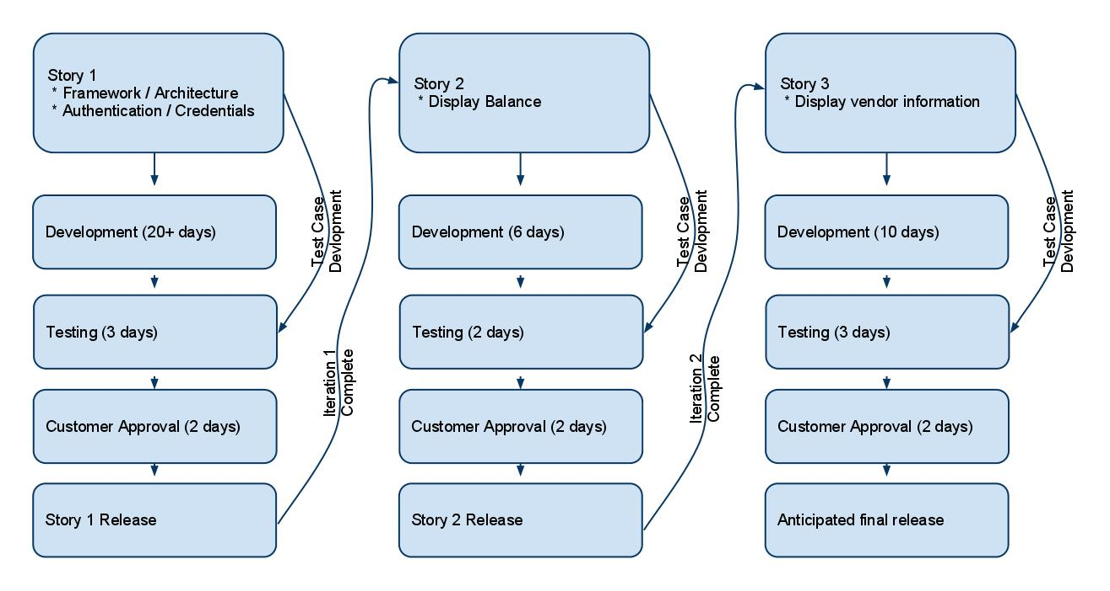

Iteration Plans
A detailed iteration plan will be provided for Iteration 1. Further task details are available in the schedule.

First Iteration
Proxy server interface functions with both the mobile iOS application and the UMKC.ManageMyID.com website. Mobile iOS application gives the user the ability to login to the website.

Second Iteration
Mobile iOS application gives user the ability to see their Roo Bucks balance.

Final Product
Proxy server interfaces with the facebook web page containing Roo Bucks merchant locations. Mobile iOS application interfaces with the proxy server, giving users the ability to see these locations.

Control Plan

Monitoring and Control
The following list of dates includes formal reviews outside of the Communication Plan. Milestones are included to reference where the project is scheduled to stand as these reviews occur:

Date | Review / Milestone
10/07/2010 | Milestone: Technical Prototype Complete
10/07/2010 | 5-Minute Status Report
10/28/2010 | Manager's Briefing
10/28/2010 | Milestone: Iteration #1 Complete
11/11/2010 | Milestone: Test Report Complete
11/16/2010 | Inspection
11/18/2010 | Milestone: Iteration #2 Complete
12/07/2010 | Milestone: Product Released
12/09/2010 | Final Presentations

Configuration Management Plan
The following procedure is to be used when making changes to all baselined work products:

- All project work products will be stored in a centralized SVN repository running on a central server.
- All baselined documents will have a Document Control section with a change history to track initialization and subsequent changes.
- All project work products (documents, source code, test cases, program data, test data, etc) will be stored in the SVN repository but not all will be under change control (subject to formal change control procedures.) Only the system requirements, project plan and source code will be baselined and under configuration control.
- Items that are subject to change control will be considered baselined after a group review at the end of the initial document creation.
- The change control procedure once a product is baselined is:
(1) anyone wanting to make a change to a baselined item sends an email to the rest of the team and project sponsor (i.e. Professor Burris) describing the change, reason for the change, expected schedule impact, and time line for integrating the change.
(2) if no one responds to the group within 2 days with a reason for why the change request shouldn't be permitted, it will be considered accepted and the person proposing the change may proceed with the change.
- if anyone does object to the change, the reason for objecting will be discussed at a meeting where everyone is invited to attend and voice their opinion. At the end of the meeting a democratic vote will be held to decide whether or not the change should be allowed.
- if a change takes place, the initiator must collaborate with the project manager to update the schedule

Supporting Process Plans

Risk Management Plan

Rank | Risk | Probability of Loss | Size of Loss | Risk Exposure | Response
1 | Schedule / time line delivery | Likely | Major | High | Mitigate: Stick to the schedule.
2 | ManageMyID website changes HTML layout | Likely | Moderate | Moderate | Avoid: Breaking the parsing engine out into a separately hosted server allows for fixes to occur in one place, instantly for all users, and with minimal intrusion.
3 | Learning curve for new tools and technologies longer than expected | Unlikely | Moderate | Moderate | Buy Information: Begin working on a basic prototype early to test out fundamental programming concepts & knowledge
4 | Data feed not available from ManageMyID website | Unlikely | Minor | Low | Avoid: Instead of using a feed from ManageMyID, depend upon logging into the site, and pull relevant information from HTML fields.

Test Plan
The test plan defines the items that will be tested, methods for testing, and a schedule detailing the tasks, owners, and time line.

The test plan will be available in a separate document in the version control system at: http://134.193.128.7/svn/cs451/branches/team1/Team1_Test_Plan.doc

Product Acceptance Plan
At the conclusion of each iteration, the prototype created will tested to ensure it meets the requirements of that iteration. An environment such as the iPhone simulator may be used to test functionality in lieu of the app being loaded on an actual smartphone.

For the final iteration, product acceptance testing will ensure that the prototype functions as expected with a user's data.

